Ernest Timkin - Dylan Ledanois - Thomas Sadurni

**Introduction**

It has been quite a few years that the ecological transition has been brought to light, but its progress is slow. However, it’s urgent to act now. In fact, the British economist Sir Nicholas Stern demonstrated that the impact on future generations will be even more severe if collective action is not taken now.

To initiate the ecological transition, one idea can be to make Environment as a global common good. Indeed, as a common good, the management of the environment is subject to the logic of the prisoner's dilemma as developed by J. Von Neuman and O. Morgenstern in their book Theory of Games and Economic Behavior (1944). Indeed, given that a country can benefit from the gains of other countries' environmental policies without suffering the costs personally, we find ourselves in a situation where the Nash equilibria of each player do not correspond to the Pareto optimum.

1. **Lack in energy**

Natural gas, coal, and oil are non-renewable energy sources and Earth reserves are constantly getting emptier. These sources of energy were formed millions of years ago, the deeper we dig into earth, the more likely it is to find natural gas and oil resources. However, the demand of such energy is getting higher and higher each year because of energy consumption and the growth of the population, and we do not have enough renewable energy to supply human’s needs.

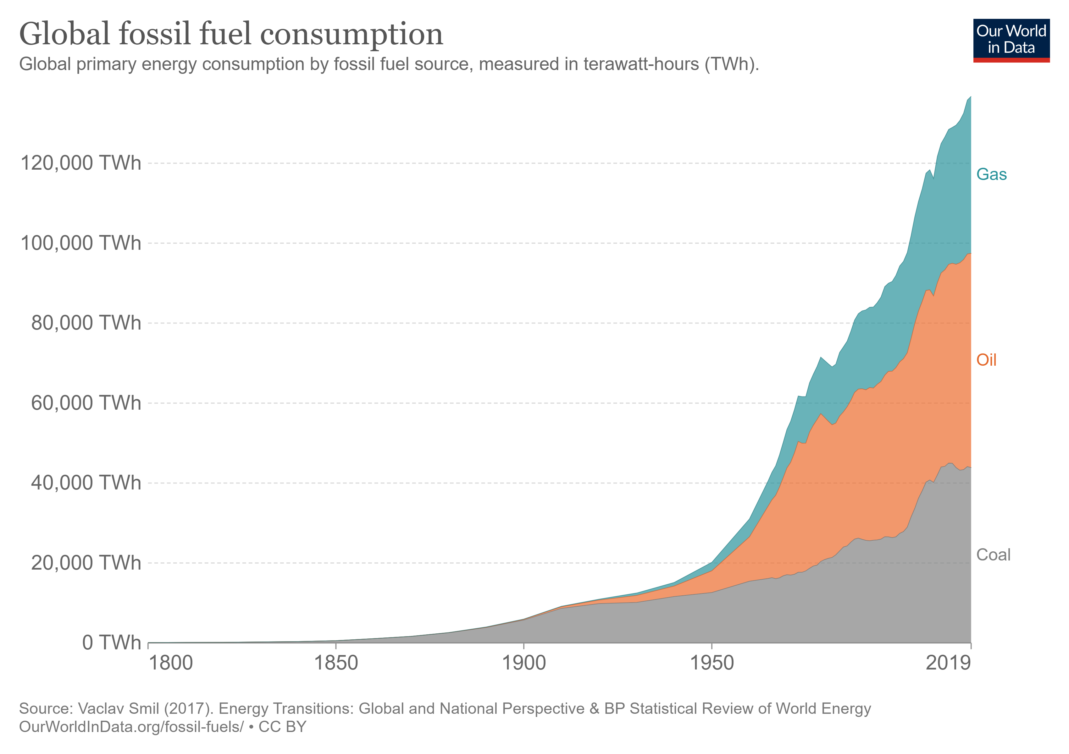

Global consumption of fossil fuels is still rising by more than 1% each year. Oil and gas firms are having their worst year for new fossil fuel discoveries in decades and reserves are getting empty. According to the following histogram, the oil and gas industry discovered only 4.7 billion barrels of oil equivalent in 2021, the worst year performance ever. Regarding the petrol, this situation may be explained by a lack of investment. Indeed, according to Amrita Sen of Energy Aspects, the sector needs "at least $520 billion in investment each year" just to maintain global production at 100 million bpd. Yet, according to his analysis, the sector is only investing $370 billion. During the pandemic, the industry was in survival mode, reducing its capital expenditures to match with low cash flows.

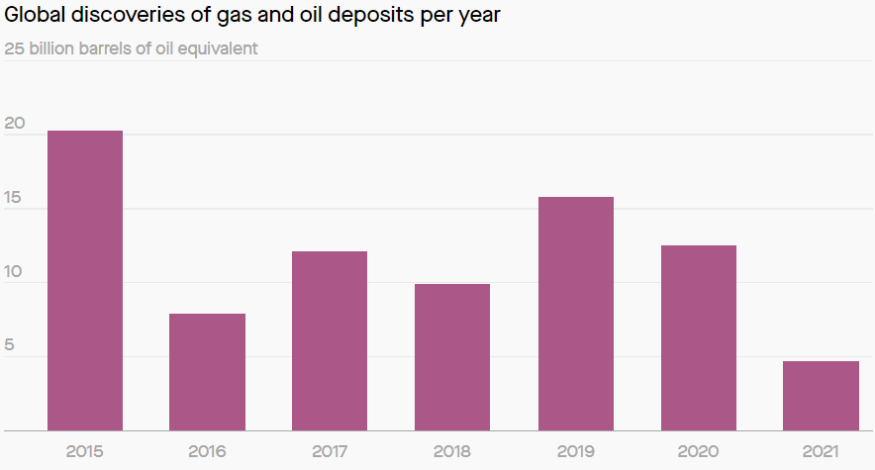

Furthermore, fossil fuels are finite and concerns surrounding this risk have persisted for a long time. This lack of energy supply is in contrast with the increase of demand, pushing up prices. New oil and gas discoveries are not certain and new ways of producing energy to decarbonize the economy needs to be deeply used if the world is serious about reaching net zero emissions by 2050. Perhaps the most important way that carbon emissions affect the planet is by causing climate change. As the average global temperature warms, our climate inherently changes — it warms. This warming causes extreme weather events like tropical storms, wildfires, severe droughts and heat waves.

Especially that for years, humanity has been pampered in extreme climatic events. The destruction of New Orleans by Hurricane Katrina in August 2005 certainly drove a message home, as well as the Hurricane Maria or Hurricane Irma in Dominica, and Saint Martin, Anguilla and other islands in Atlantics respectively, two category 5 hurricanes which caused more than 200 deaths.

By 2030, the average sea level in south-east Florida is likely to be six to ten inches above the mean level seen in 1992; by 2060, between 14 and 26 inches. By 2100, the Atlantic could devastate the area because of Florida’s porous limestone bedrock and shallow water table, which allow water to well up even behind sea walls.

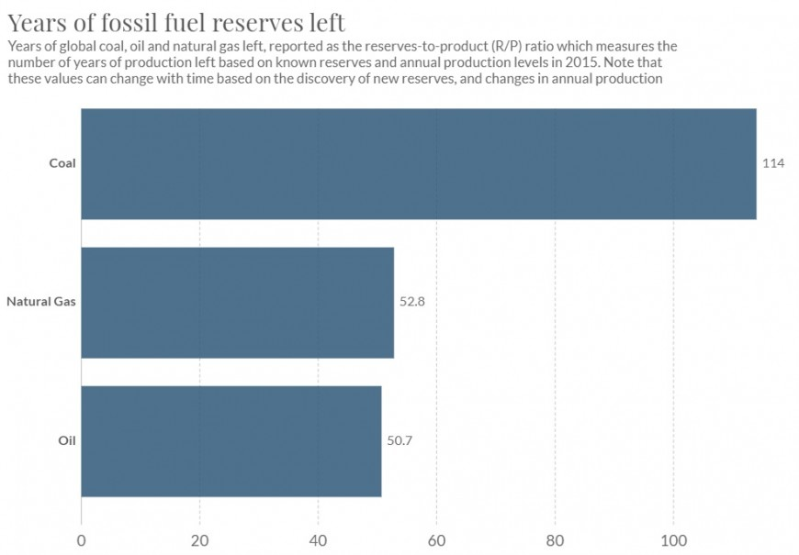

Carbon dioxide emissions remain trapped in the atmosphere for long periods of time, building up an atmospheric stock that leads temperatures to rise. To keep average global temperature, increase below two degrees Celsius, we can thus calculate the cumulative amount of carbon dioxide we can emit while maintaining a probability of remaining below this target temperature. This is what we define as a ‘carbon budget’. In the following chart, we can the date at which the country's ecological footprint exceeds the planet's capacity for renewal. Things need to change. 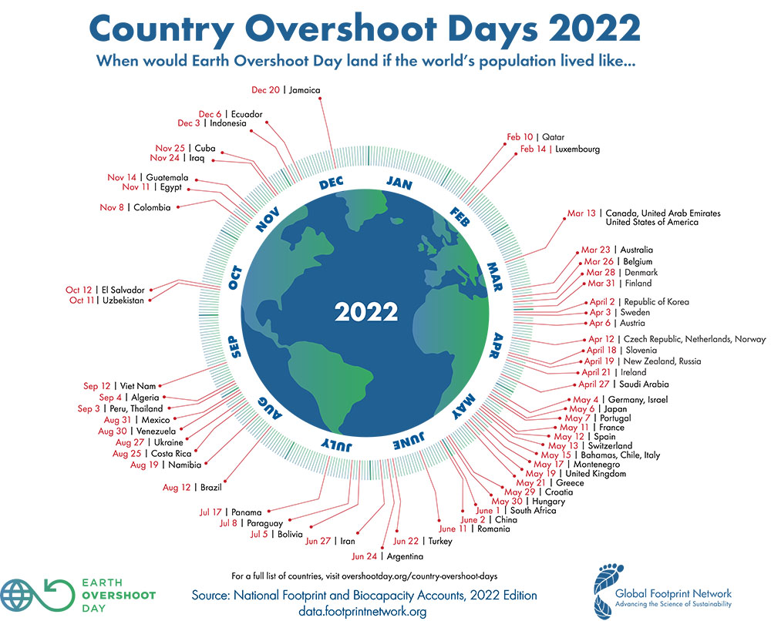

What type of scenario will happen if we run out of fossil fuels?

* Electricity failure
* Global transportation will fall
* Food chain logistics will be disrupted

We do not just have to reduce our consumption of fossil fuels and switch to green energy because we run out of supplies, but also because coal and oil are harming our environment badly. Renewables only provide 5% of our energy needs, while nuclear energy supports our demand with 4% of energy. Nuclear power plants are also safe sources of energy, the problem is the storing of nuclear waste.

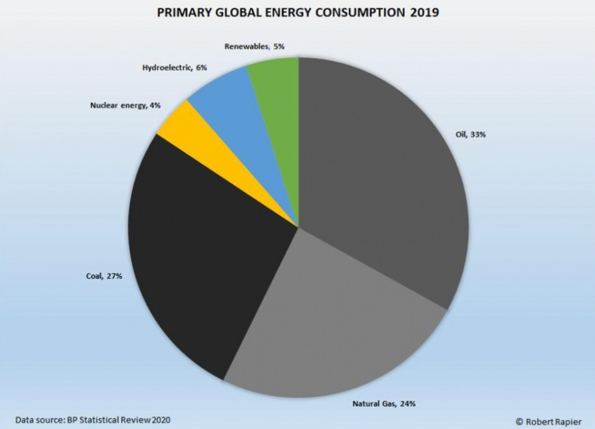

Right now, we are seeking out renewable energy, such as wind, solar, hydro, and biomass.

More than 80% of new electricity generating projects built last year were renewable. It has led to a 10.3% rise in total installed [zero-carbon electricity generation](https://www.forbes.com/sites/davidrvetter/2021/04/07/2020-set-a-new-record-for-renewable-energy-whats-the-catch/?sh=3e4390cc204d) globally.

1. **How to achieve energy transition?**

The European Union set out a goal to achieve carbon neutrality by 2050. This goal involves following several actions:

1. Change current energy production to decarbonized ways of producing energy such as biomass resources, geothermal energy, heat pumps, carbon-free electricity (nuclear & renewables).
2. Reduce energy consumption in all industries
3. Reduce emissions unrelated to energy consumption
4. Increase carbon sinks to absorb emissions

These action plan helps to reduce the emissions and promotes energy transition.

Carbon offsetting is a mechanism for financing environmentally beneficial projects through the generation of "carbon credits" sold to third parties to offset their own GHG emissions. Allowing for climate solidarity on a global scale, this mechanism is essential to accelerate the decarbonization of our ecosystem. However, to display a lower GHG impact (or even carbon neutrality), some players prefer to finance emission reduction or sequestration projects with third parties, as they are often less expensive than investing in a real decarbonization project for their own activities.

5 best practices for voluntary carbon offsetting:

* Make and publish a balance sheet of emissions, reductions and offsets
* Choose certified offset projects
* Give priority to projects with a "sustainable development" approach
* Define the right mix of projects supported on national soil and projects supported internationally
* Communicate responsibly

The Nuclear energy is more and more considered as a mean to replace gas and oil consumption. However, it still generates waste that harms the nature. With new technologies there could be found a way to reuse the nuclear waste, but it is not the case today. That is why, some countries such as US are planning to reduce nuclear energy production. According to the report of McKinsey & Company, US is going to reduce nuclear, gas, coal and oil energy production by 2035. To meet increasing energy demand US is planning to compensate these sources of energy with mainly onshore wind and solar energy production.

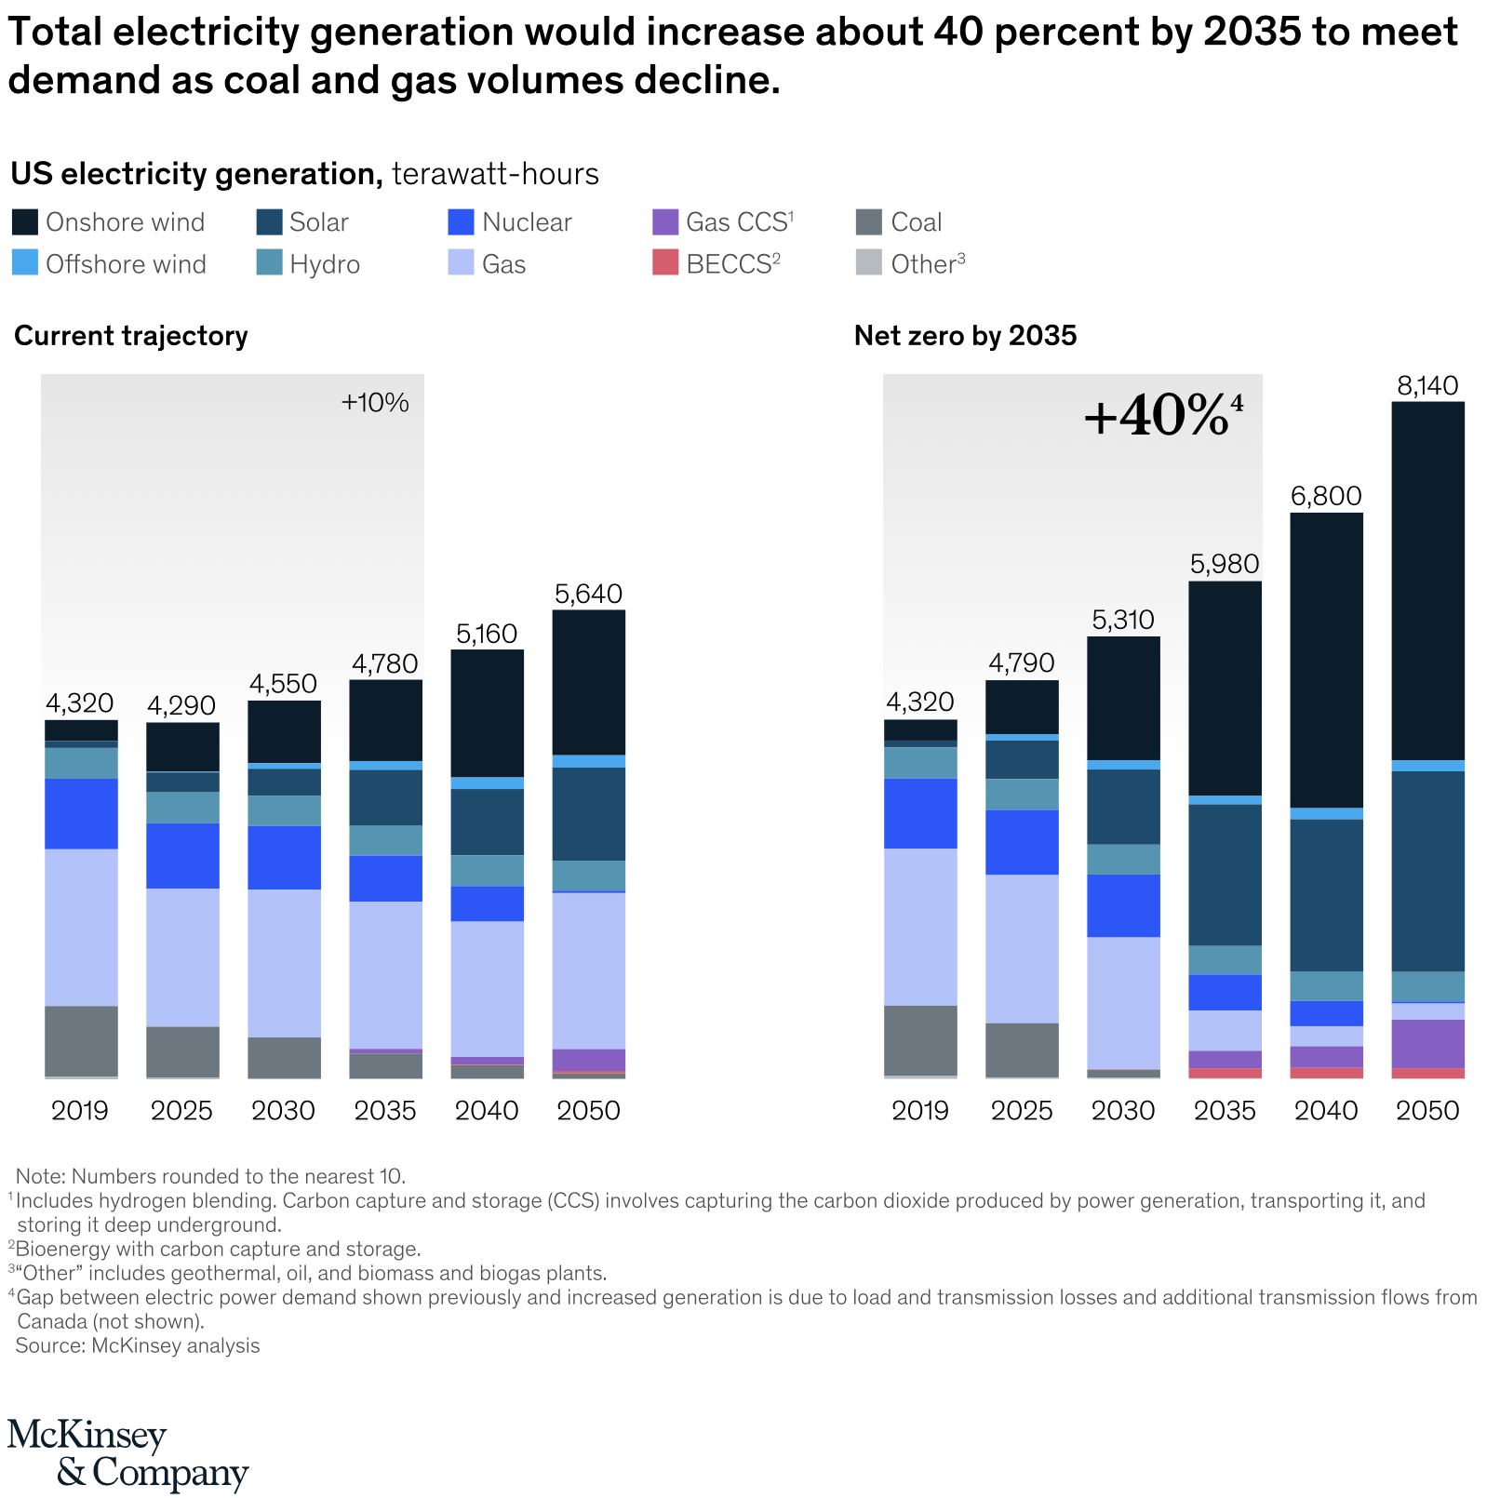

In addition, current geopolitical situation in the world can speed up the energy transition since the tensions between west countries and Russia (one of the largest suppliers of gas and oil to EU) intensify. For example, the escalation of conflict between Russia and Ukraine caused a new wave of sanctions against Russia such as freezing the project - Nord Stream 2 pipeline. This situation is forcing the European Union to reconsider the benefits and trade-offs of using gas and think about an early transit to renewable energy since it does not have alternatives for gas supply. Such early transit might require governments to invest more in renewable energy projects and concentrate their budgets on this issue in order to get flexibility of decisions in relationships with east countries.

Lastly, the COVID-19 crisis helped a lot in energy transition. According to Global Energy Perspective 2021 report by McKinsey & Company, the changes caused by COVID-19 crisis reduced global oil demand. These changes are mainly related to behavioral shifts and working environment such as reduced willingness of people to fly and increased remote working. In the same report it can be noticed that the global energy transition is coherent with US position where the main sources of future energy come from solar and onshore wind energy production.

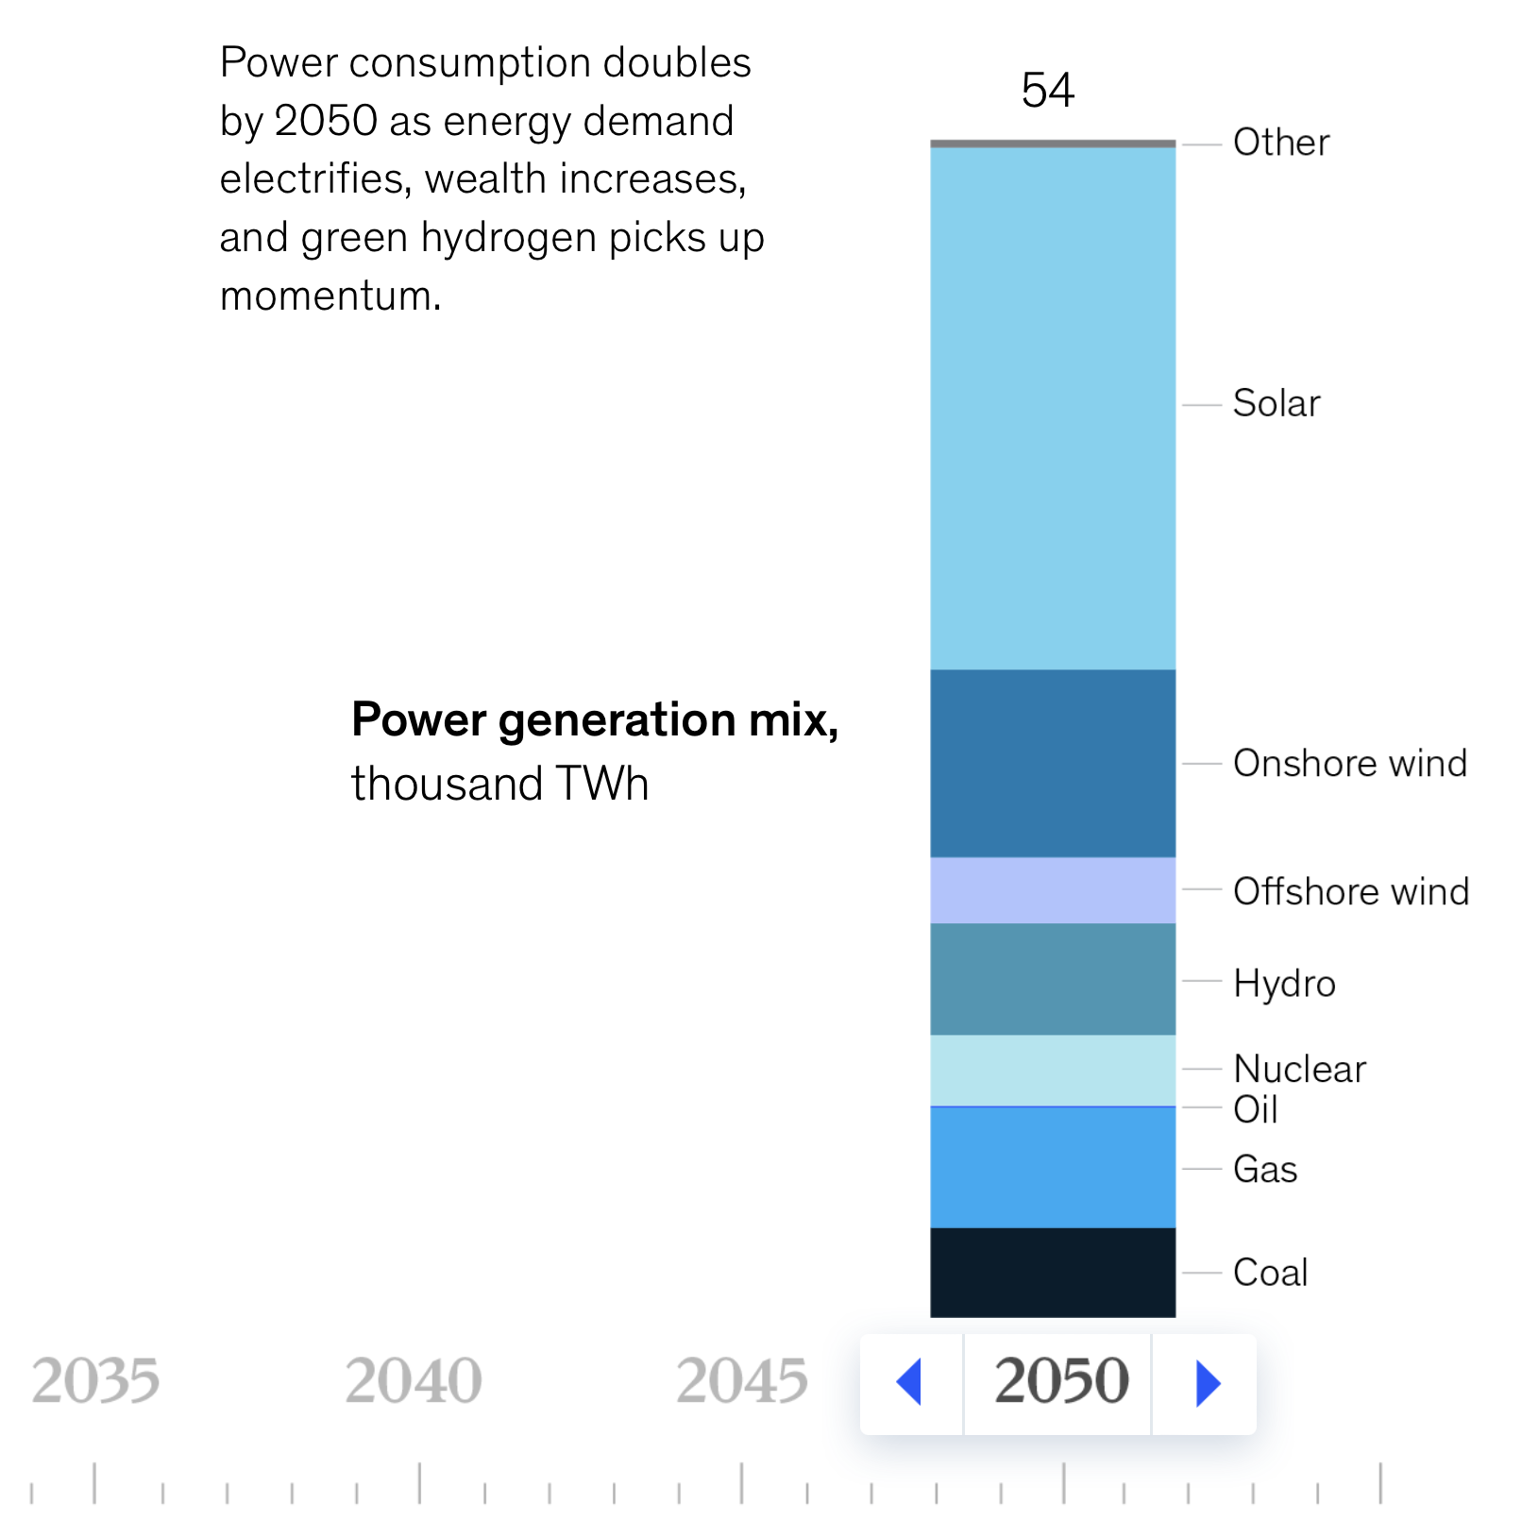

**Conclusion**

It is predicted that we will run out of fossil fuels in this century. Oil can last up to 50 years, natural gas up to 53 years, and coal up to 114 years. Yet, renewable energy is not popular enough, so emptying our reserves can speed up.

However, it is sad. Sad in 2022 to have a war in Europe. But realistic. For years we have known that behind the energy transition lies a boiling cauldron, a war for raw materials and, for countries dependent on hydrocarbons, an urgent reconversion to be undertaken to remain sovereign by 2050 when oil and gas will no longer be a force of strength. We must help governments identify ambitious but achievable goals, and then to achieve them in the most cost-effective manner. Our efforts have so far been a fraction of what is required. We are neither on track to achieve internationally agreed goals nor managing to execute even the existing policies in a cost-effective way. This is placing human well-being at risk.  
  
There is only one way forward: governments need to put together the optimal policy mix to eliminate emissions from fossil fuels in the second half of the century. Cherry-picking a few easy measures will not do the trick. There must be progress on every front, notably with respect to carbon pricing, and that is what peer review and learning from best practice should help achieve.